

Dr. Joseph, Costa inc.
2023-12-24
Dr. Costa
287 Laura Ports, North Lisa, ME 15021
Phone: 8907721316
Fax: 9009738549

Re: Anita, Moore
PHN: 6684888814
Birthdate: 10-Feb-1966
Address: 174 Lloyd Trafficway Suite 469, Lake Logan, WI 24320
Patient number: 1051852661

To Whom It May Concern:

This is a medical letter to state the above patient is pregnant with expected delivery date of 19-Feb-2025. Hoping this information is satisfactory for your requirements.

Thank you.

Sincerely,
Dr. Joseph, Costa
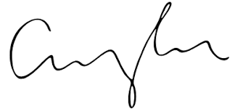
FRCS© NCMP
Clinical Assistant Professor, UBC
Department of Obstetrics and Gynecology SMH

